**STEP 1** – ENSURE YOUR POSTURE IS CORRECT FROM THE START – CHECKING YOUR FOOT PLACEMENT, HIPS, BACK, NECK.

**STEP 2** – START YOUR SQUAT, ALL WEIGHT IN THE HEELS, KNEES NOT EDGING OVER THE TOES, BACK STRAIGHT, CHEST UP, HEAD FACING FORWARDS.

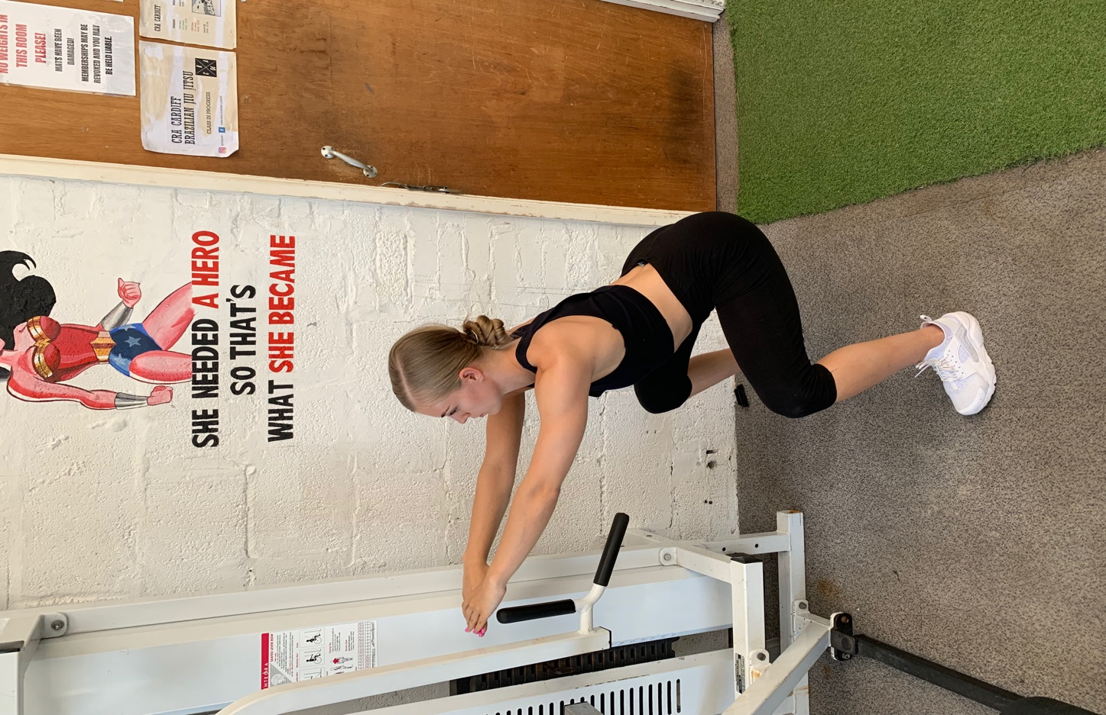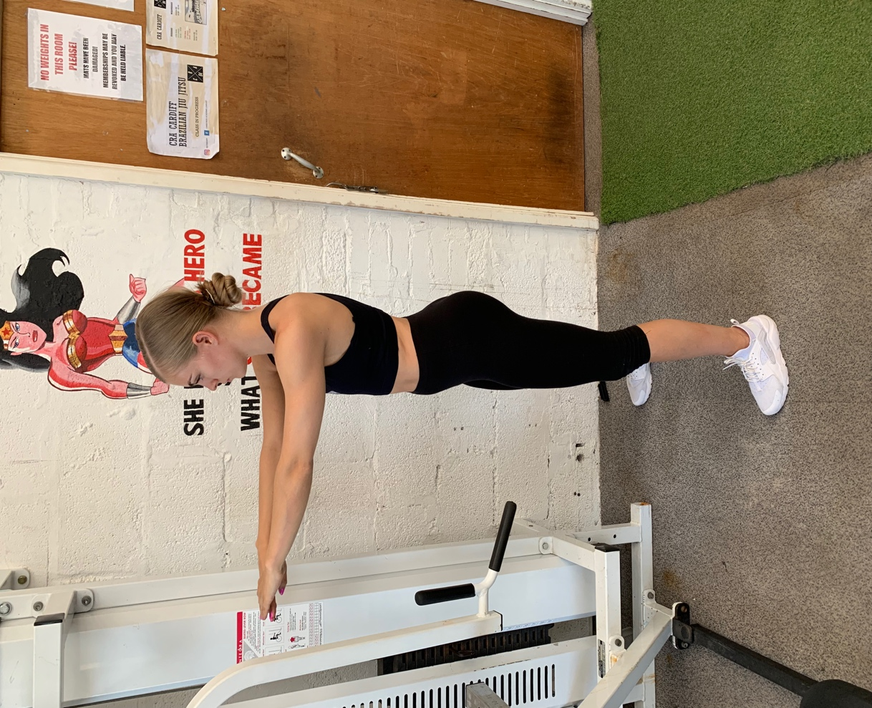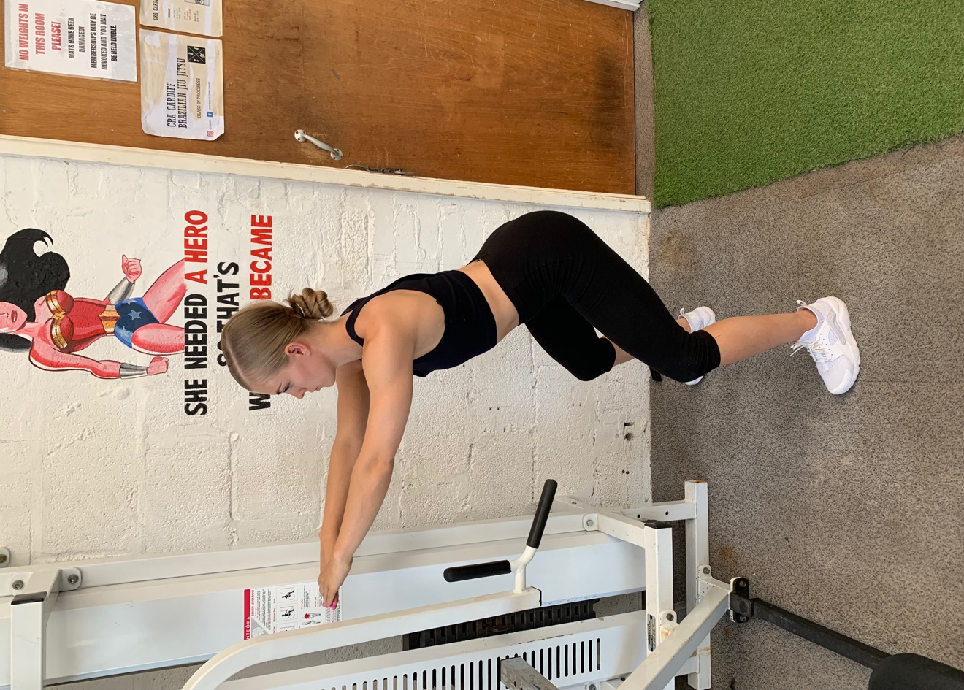

**STEP 3** – FULL SQUAT, GOING DOWN QUITE LOW – YOU DON’T NEED TO GO TOO LOW, BUT THE LOWER YOU GO THE MORE MUSCLE YOU USE. HOWEVER, IF YOU LOSE YOUR TECHNIQUE GOING LOWER, AVOID IT UNTIL YOUR POSITION IS SAFE.

KEEP THE WEIGHT IN THE HEELS, KNEES NOT EDGING OVER THE TOES, BUTT OUTWARDS, NEUTRAL SPINE, CHEST UP, HEAD FACING FORWARDS.

AVOID DROPPING THE CHEST

DOWNWARDS, THIS MAKES IT DIFFUCLT TO PERFORM THE SQUAT & CAN BE HIGHLY DANGEROUS IF SQUATTING WITH WEIGHT.

AVOID TILTING THE BODY WEIGHT

ONTO THE TIP TOES, THIS WILL AFFECT THE REST OF YOUR BODY POSTURE AND IS THE INCORRECT WAY TO SUQAT!

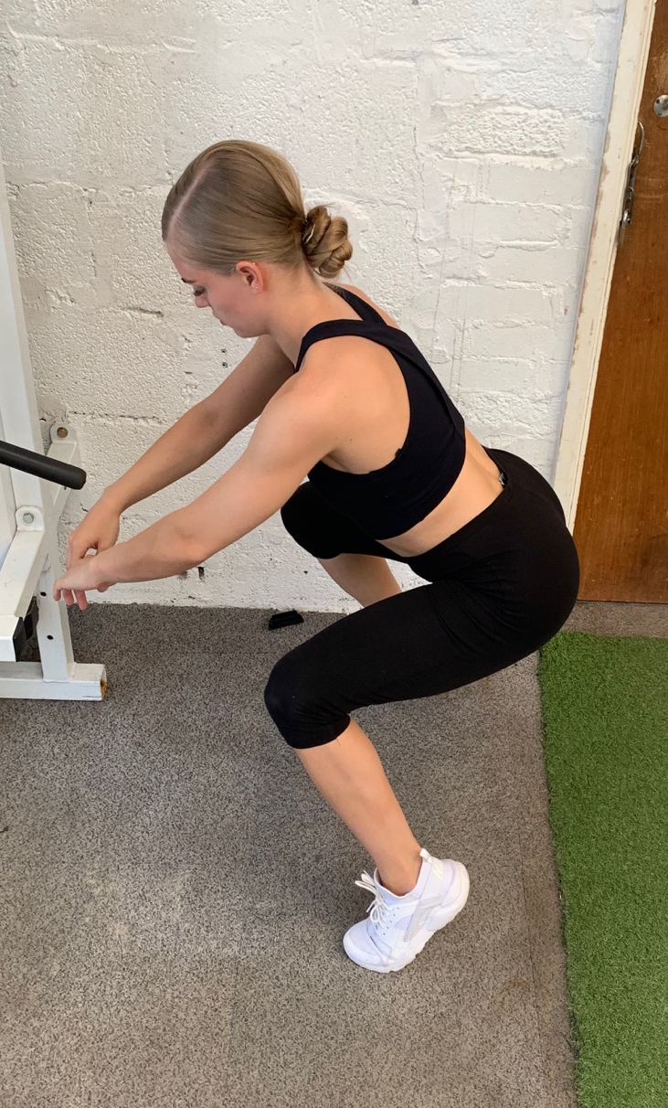

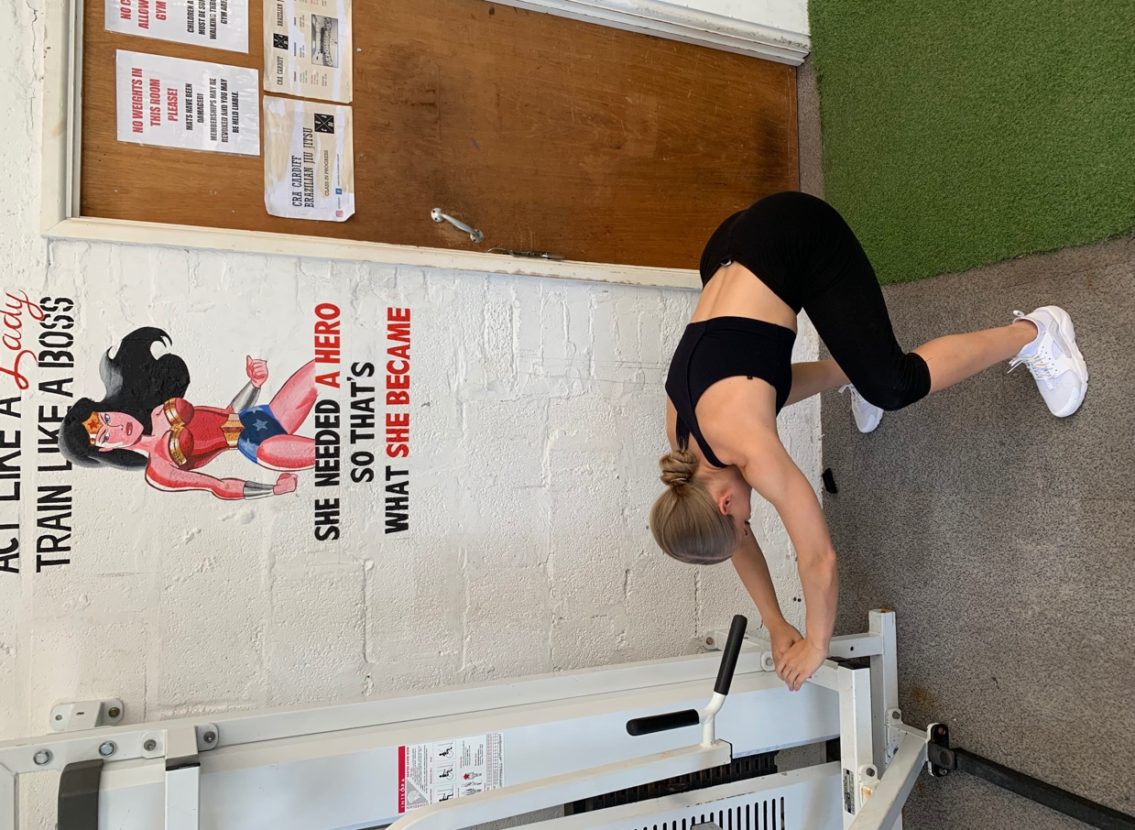

Please copy & paste the following link into YouTube if you want to view a quick video of the correct way to Squat! -

https://youtu.be/D624Y6tVoBQ